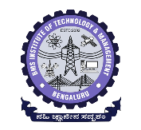
BMS INSTITUTE OF TECHNOLOGY & MANAGEMENT
(An Autonomous Institution, Affiliated to VTU,Belagavi)
Avalahalli, Doddaballapura Main Road, Yelahanka, Bangalore-64
Department of MCA
Project Based Learning- Synopsis
Student Name: USN:
Student Name: USN:
Date of Submission:
Project Title:
Sl. No | Particulars | Remarks
 | Introduction
 | Objectives
 | Literature Survey
 | Existing System
 | Proposed System
 | Modules Identified
 | Hardware and Software Requirements
 | SDG Alignment
 | Work Breakdown Structure(Gantt chart)

Recommendations: Accepted (Y/N)

Suggestions by the coordinators:

/10
Evaluation by Guide:

Signature of coordinators

